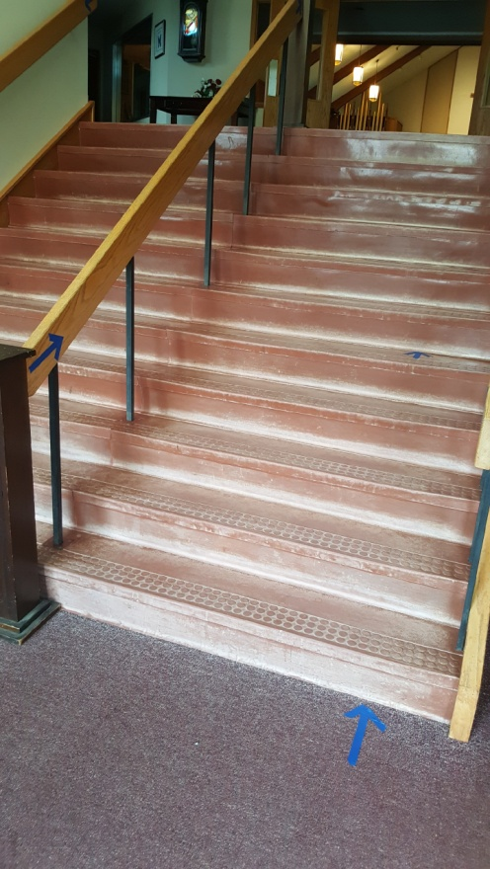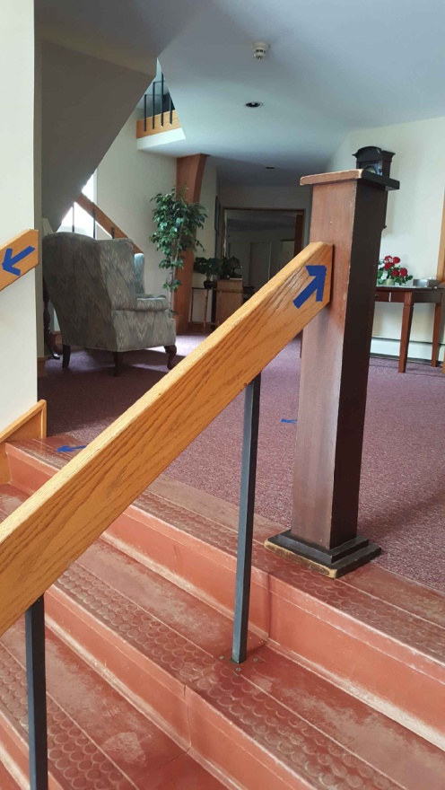
Stairs contain arrows to help keep the traffic to flow up on the right when entering & down on the right when exiting. A stand at the top & bottom of the stairs will have hand sanitizer. There is also a sanitizing station just inside the sanctuary doors.

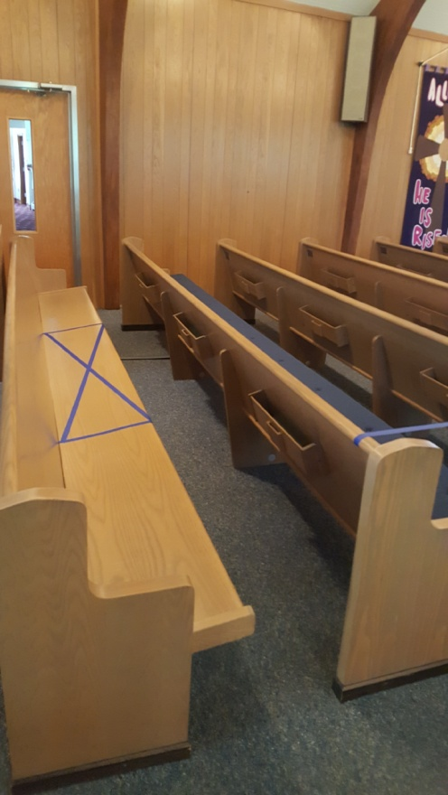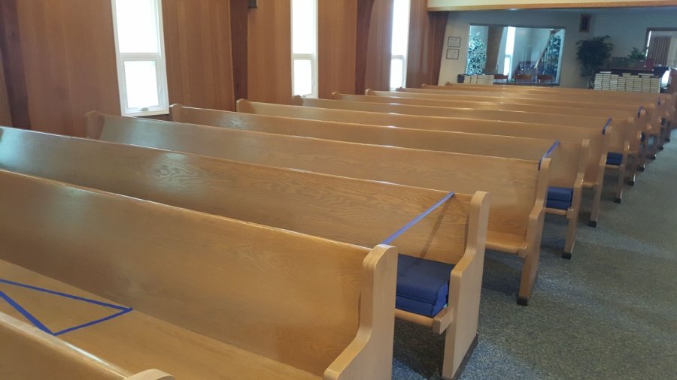
Every other pew is blocked off, and a 6 ft. section has been placed in the center of the pews indicating where NOT to sit, leaving enough room at each end for two persons (or a couple with a small child). However, a larger amount of members from the same household can occupy an entire pew. All pews have been sanitized, and pew cushions are doubled up on the pews that are not to be used. Bulletins will be placed on the pews where seating is available.

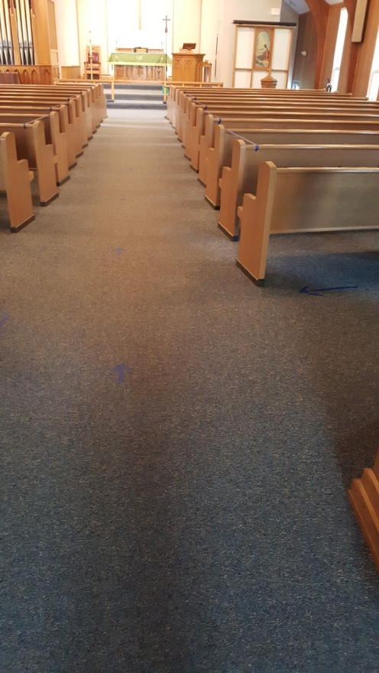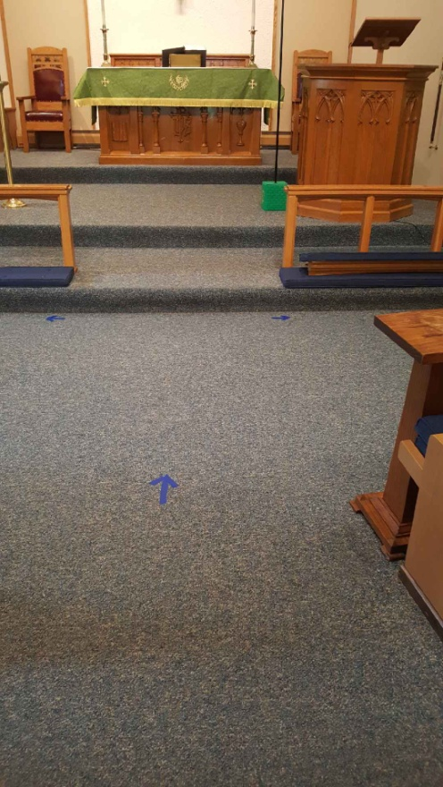
Arrows have been placed six feet apart in order to indicate direction and social distancing. Entrance into the sanctuary is one-directional down the center aisle, as well as to proceed forward for communion. A hand sanitizer will be placed on the small table on the right for sanitizing prior to receiving communion.

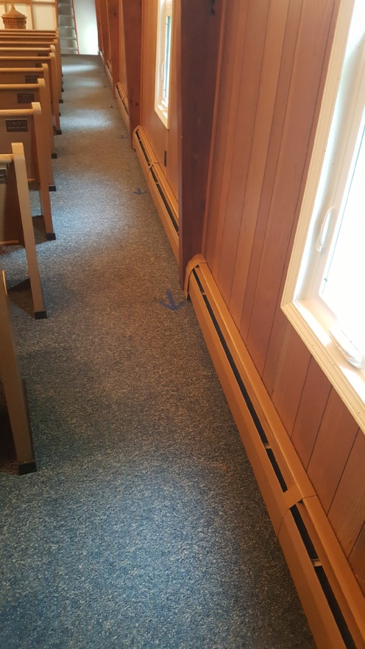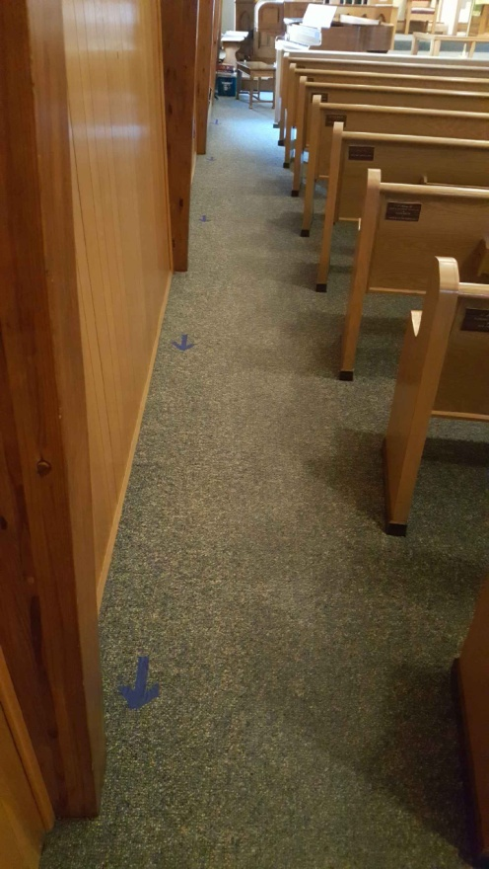
After communion, parishioners must follow arrows along the wall back to their pew, and then again when exiting the sanctuary after church service. Those seated on the right side of the church will exit the main doors to the parking lot; those seated on the left will exit down the hall past the offices and out the south doors to the parking lot.

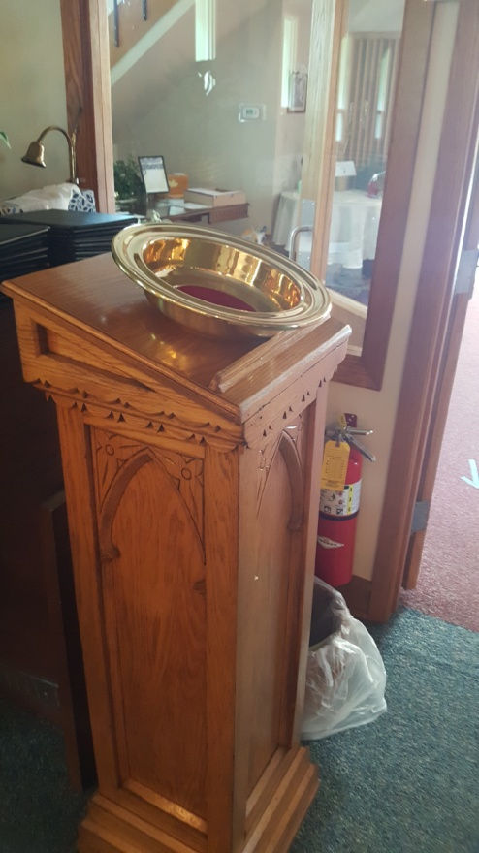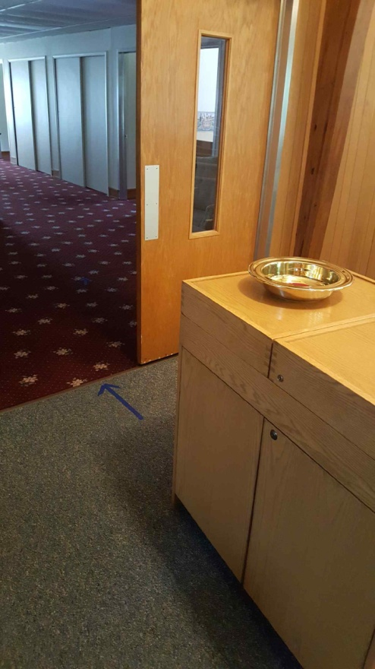
Offering plates are located at each exit. Offering envelopes may be placed when entering or exiting the sanctuary. The offering counters can collect both plates once everyone has exited the sanctuary.

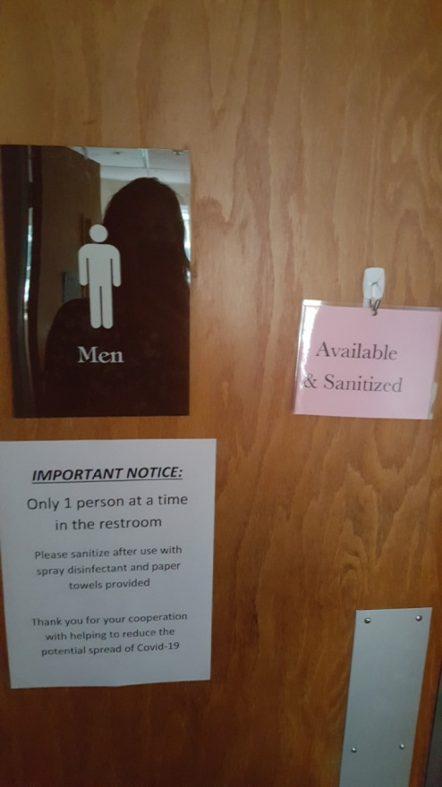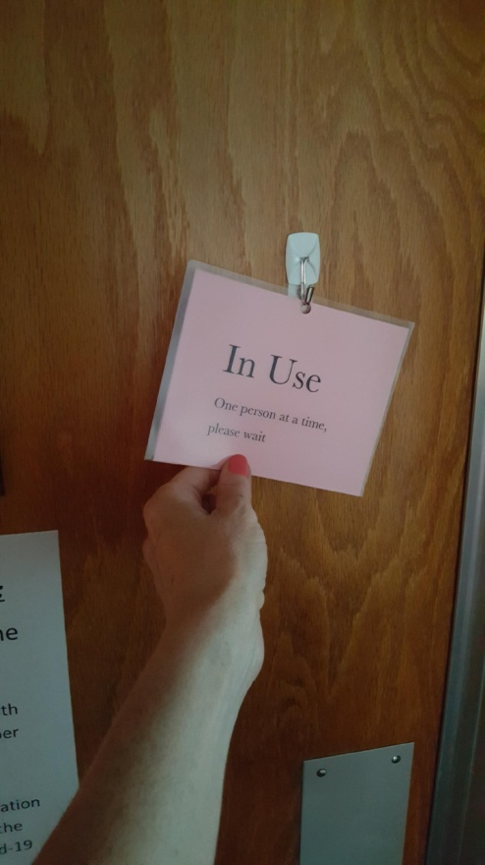
All restrooms need to be occupied by one person at a time. Please turn the sign to show when ‘in use’ and then back to available once you leave and have sanitized.

